What is the overall business performance of the supply chain?

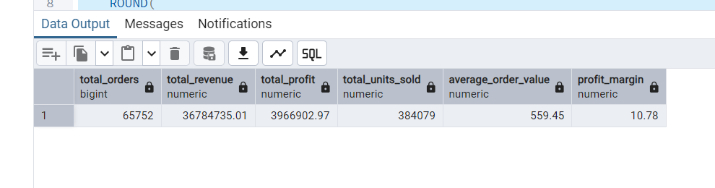

How effectively is the supply chain meeting delivery expectations?

=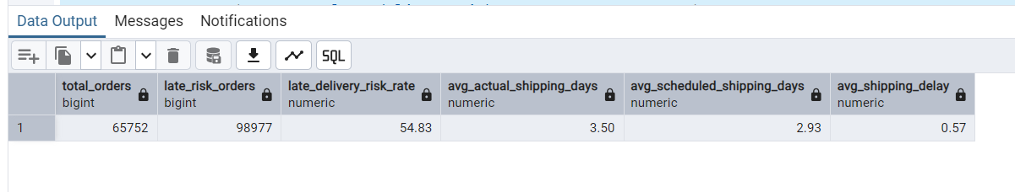

Which product categories drive the most revenue and profit?
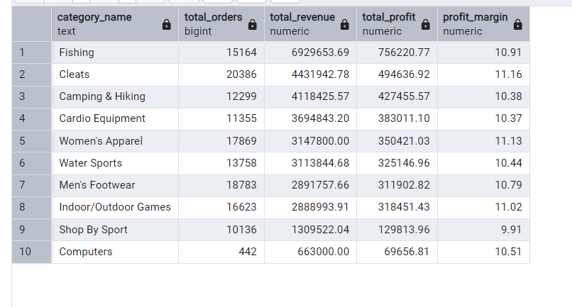
Which regions generate the most revenue and profit?
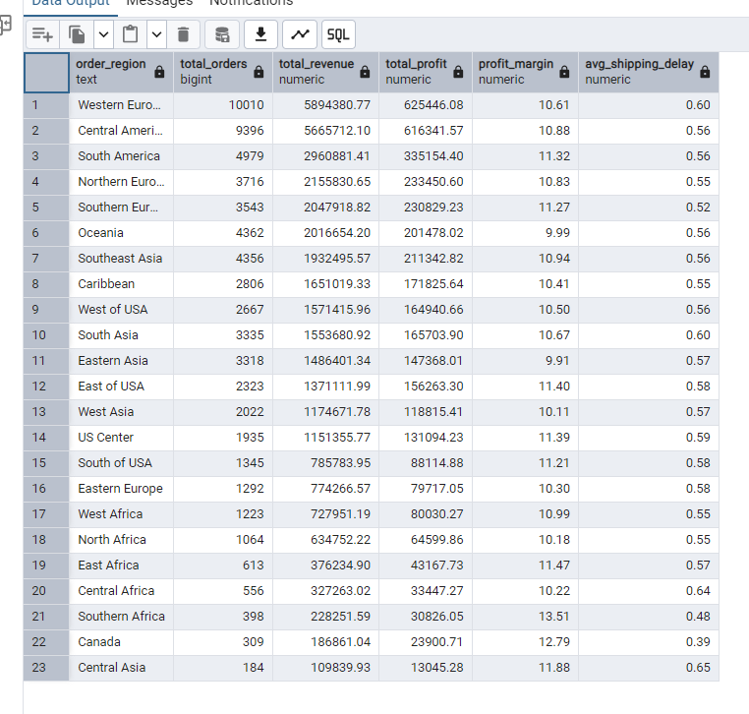

How do shipping modes differ in shipping time, delay, and late-delivery risk?
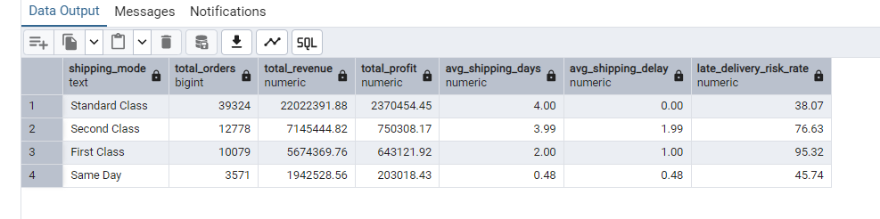

How does discount level relate to revenue and profit margin?
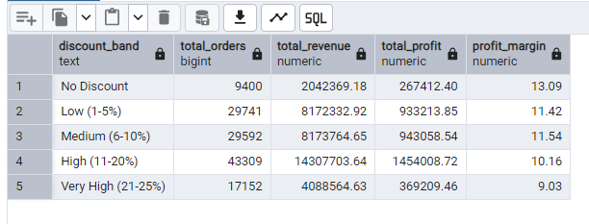

How has revenue changed over time?
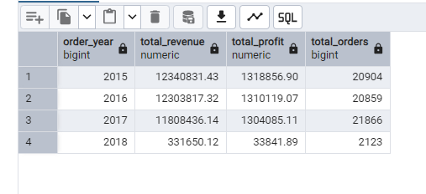

Which products generate the most revenue?
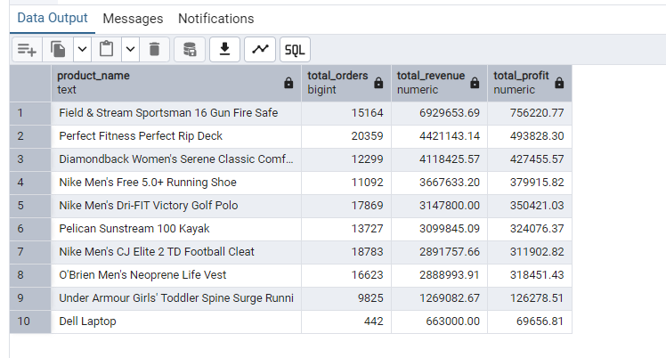

Where are delivery risks highest?
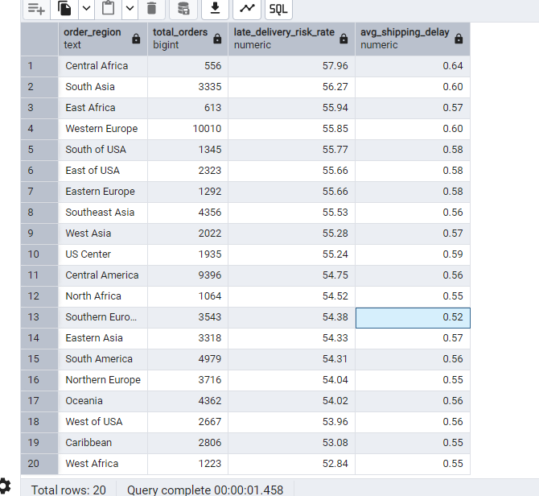

Which customer segments generate the most value
